Smart Viewer Quick User Guide
- Overview
- Setting Up Smart Viewer
  - Launching Smart Viewer for the First Time
  - Adding DVRs
  - Naming Devices
  - Backing up Devices
  - Restoring Device from Backup
- Using Smart Viewer
  - Connecting to a DVR
  - Reviewing Footage
  - Exporting and Saving Footage

Overview
Smart Viewer is software that can be used to remotely view the cameras connected to a Samsung DVR. It is full featured and can save settings for each DVR that you connect to. Before you can connect to any of your DVRs you will need to have Hamachi running.

Setting Up Smart Viewer
Detailed instructions for installing SmartViewer can be found in SmartViewer Installation Guide

Launching Smart Viewer for the First Time
After installing Smart Viewer you should have a desktop shortcut and a start menu shortcut. Use one of these to open the application.
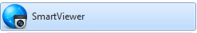
The first time you open Smart Viewer you will be prompted to set up an admin password. This password is used to log into the application and does not need to match or affect the password for any of your DRVs.
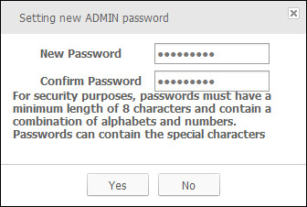

Adding DVRs
Before adding DVRs you will need to have installed and be running Hamachi.
Click on the gear icon in the top right corner of the window to open the settings window.
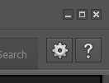
Click on the Device tab at the top of the window.
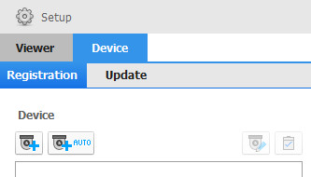
Click the Add DVR button. 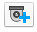
Enter the IP address for the kiosk you want to connect to as well as the device port 4520 and the ID is always admin and password according to the DVR model. For the Samsung SRD-440 the password is 4321. For the Samsung SRD-443 it is a1234567. Click the Register button to save it.
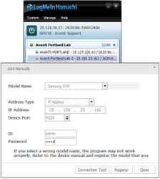
The DVR will now appear in the list of available devices in the top left corner of the main window.
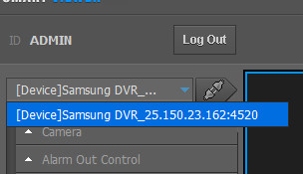

Naming Devices
You can give the DVRs easy to remember names. It is suggested that you do not change the entire name but rather add a word or two at the start.
Click the gear icon to open the settings menu and then click the Device tab. Select the DVR you want to edit and click the edit icon.
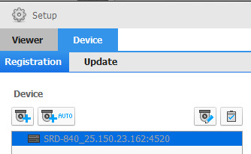
Make the desired changes then click Modify.
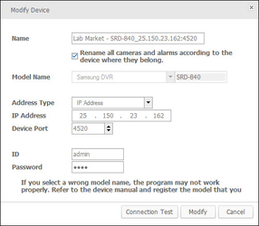

Backing up Devices
Click on the gear icon in the top right corner of the window to open the settings window.
Click the Update tab in the setup window.
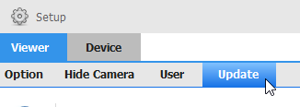
Check Device boxe and click Export Configuration.
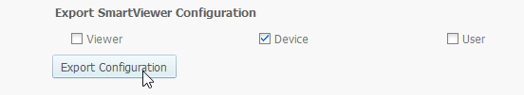
Save the file in a safe place.

Restoring Device from Backup
Click on the gear icon in the top right corner of the window to open the settings window.
Click the Update tab in the setup window.
put a check mark next to Device and click ... to choose th backup file that you created. Click Import Configuration to import it.
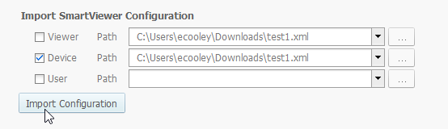

Using Smart Viewer

Connecting to a DVR
After you have added your DVRs they will appear in the drop down menu in the top left corner of the window. After you select the DVR click the connect icon to start the connection.
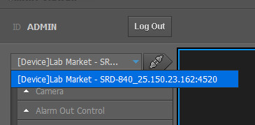

Reviewing Footage
Click the Search Tab in the top right of the main window after you have connected to the DVR you would like to review footage from.
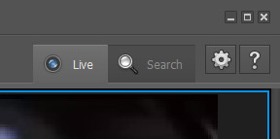
Use the calendar on the left to select the date and the time slider at the bottom of the screen to choose the time to review.
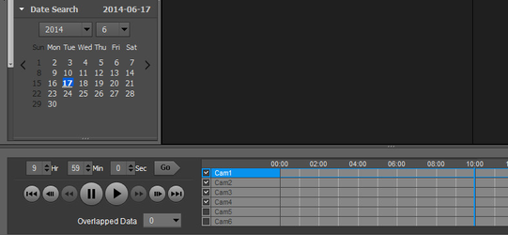

Exporting and Saving Footage
It is not recommended that more than a few minutes of footage be downloaded from a kiosk that is using a wireless internet connection as it will exceed the data cap, take a very long time and impact the performance of the kiosk. To save large amounts of footage it is recommended that this is done directly from the DVR in the kiosk using a portable USB storage device.
Before you backup footage you will need to determine the time frame you would like to back up. While in the search window and with the correct date selected click the backup icon along the bottom edge of the window.
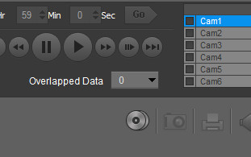
Specify the cameras and time frame to be downloaded.
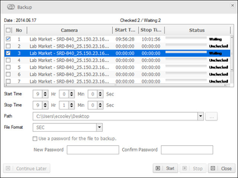
Click the start button to begin the download.
The progress of the download will be displayed.
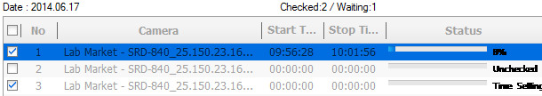
It will be saved to the path listed.
Two files will be created for every camera that is exported. The .dll file is used by the .exe file so make sure to include it if you are providing the footage to another party.

