SmartViewer Installation Guide
SmartViewer Installation Guide
The most recent version of SmartViewer can be found at this address:
- https://www.hanwhasecurity.com/smart-viewer.html
Place that address into a web browser and hit enter. Once the page has loaded, scroll down until you see the RESOURCE DOWNLOAD section.
Choose the software tab and click the download button to the right of it.
Once the SmartViewer zip file has been downloaded, find the download (most likely in your Downloads folder) and right click the zip file.
In the menu that has popped up when you right click on the zip file you will find an entry titled "Extract All". Click Extract All.
Windows will then ask where you would like to download this file. Click Extract and then wait for the zip file to be extracted to the destination folder. In this example, the destination location is
C:\Users\username\Desktop\"SmartViewer software v4.5 (Full)_20141212"
Once the zip file extraction has completed, the folder that it was extracted to may automatically open. If it does not, navigate to the folder that you designated the file should be extracted to.
Once in the extracted folder, click on "SmartViewerSetup" and follow the installation wizard until you have completed the installation process.
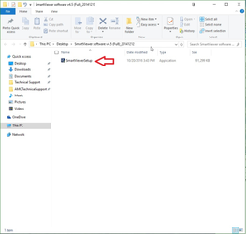
You will likely be prompted initially to authorize the installation. If so, please do so.
After providing authorization to install SmartViewer the SmartViewer Installation Wizard will load to guide you through the installation process. Start the process by clicking the "Next >" button.
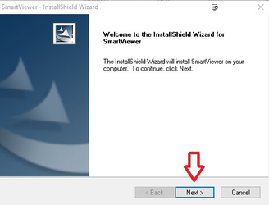
You will then be prompted to choose a destination folder for the SmartViewer application files. Your pc should already designate the installation folder as shown below, so we can hit the "Next >" button to choose to install to the C:\ drive.
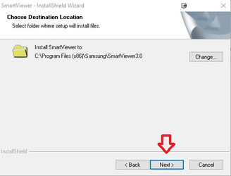
After designating an installation folder you will be prompted to start the build of the application folder and files. Click the "Next >" button to start this.
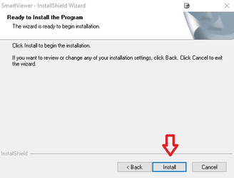
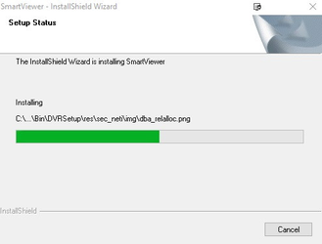
Finally, we have completed the installation process. Click "Finish" and the Installation Wizard will close.
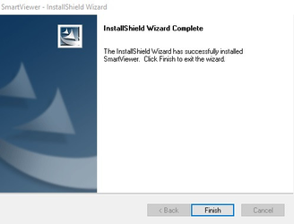
As part of the installation process you will be prompted to create an admin login. Please be sure to write this down as we will not have access to this password nor ability to reset it for you.
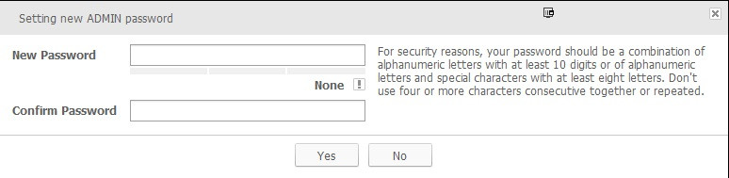
You can now use the username admin and the password you have created to log in to SmartViewer and connect to the DVRs in your Hamachi group.

