No Touch Purchase Experience
At this time, consumers may prefer to make their market purchases without touching the kiosk screen.
Market users can accomplish this in a few easy ways.
- Instead of touching the kiosk screen to navigate through purchase options and select payment method, use a stylus pen or cover your finger with a napkin or other thin piece of cloth. Although a longer press may be necessary to register, the kiosk should still register your selection.

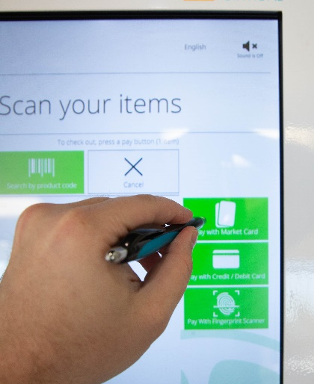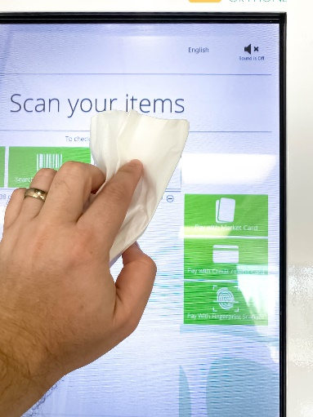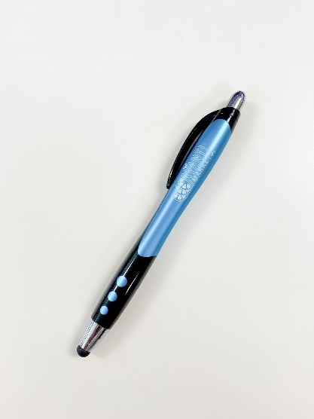

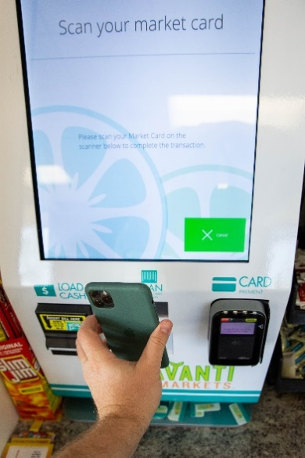
- After scanning your items for purchase and selecting your payment method, pay using your mobile phone or market card to avoid use of the fingerprint scanner. You can also still pay with a credit/debit card.

