Welcome to Avanti Markets!
We are excited for you to become part of Avanti Markets.
We are happy to assist you to begin the new journey and guide you through. Below are some instructions that you will find helpful when installing our market.
- How to notify your staff
Attached to the email, you will receive a document titled “Grand Opening”. This is a document for you to print, email, and share with your staff to get them excited about the new market install!

- How to prepare the space
When we install a new market, we advise to have a clear space prepared for the installation. It is very important to make sure there is enough room to install the market.

This means:

Make sure there is a clear path for our installers.
Please understand that our installers need a clear path for safety and have enough room to bring and install our machines. This means unnecessary items such as furniture or stored items should be removed as well.

Double check your power requirements.
Please make sure that you have read and have understood our ‘Power Requirements’ guide. This is important when installing new market for our installers to connect all our machine to power and run smoothly. This means all designated plugins for equipment are powered properly and ready to go.

Double check the ‘Network Requirements’.
‘Network Requirements’ is as important as ‘Power Requirements’. Please make sure that you have read and understood what the requirements are. When installing, having a properly working network is essential. Make sure that the hardwired connection is functioning and ready to go.

Thank you for choosing Avanti Markets. We are very excited to begin our journey together!

Avanti Markets Inc.
1217 SW 7TH ST #100 RENTON WA 98057 / (888) 937.2826 / AVANTIMARKETS.COM

Welcome to Avanti Markets!
We are excited for you to become part of Avanti Markets. We are happy to assist you to begin the new journey and guide you through. Below are some instructions that you will find helpful when setting up and using your new market account.

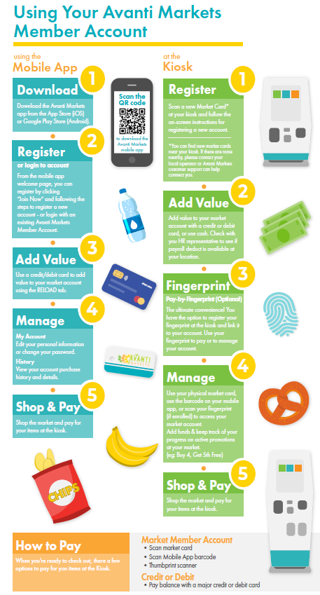

Dear Employees,

We are excited to bring you a new employee benefit to our work environment that provides you with exceptional food and beverage services! Avanti Markets will be your new convenient micro market that will provide you with an almost limitless selection of fresh food meal options, snacks and a variety of beverage choices!

We hope to support your work-life balance with the convenience of an Avanti Market in our workplace. You will find this market to be reasonably priced, simple to use, convenient for everyone and completely customizable to your personal needs. If you want something in your market, they can most likely provide it!

Grand Opening Date:
Location:
Time:

You are encouraged to download the Avanti Markets app (avantimarkets.com/mobileapp) prior to our opening event. You'll be able to pre-register and account and even load funds to your card so you are ready to use the market right away! You can also register at the market with a physical card that will be provided. Join the fun experience at the grand opening and we look forward to seeing you there!

We hope you enjoy the market!

Sincerely,

