**Symbol LS2208 Barcode Program Sheet**

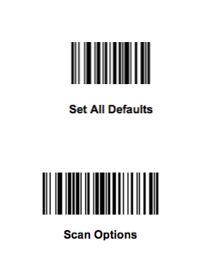

1

2

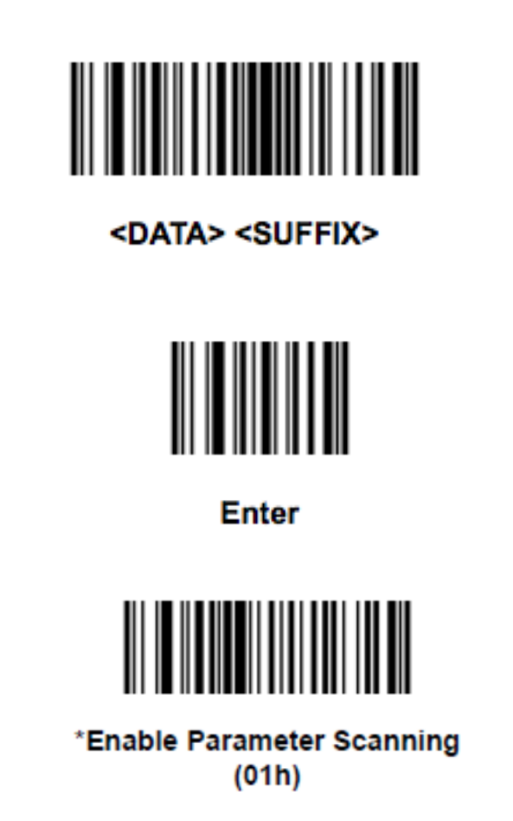

3

4

5