Symbol LS2208 Barcode Program Sheet
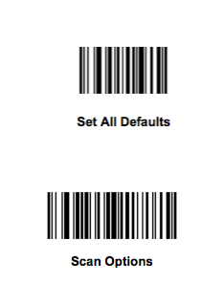

1

2
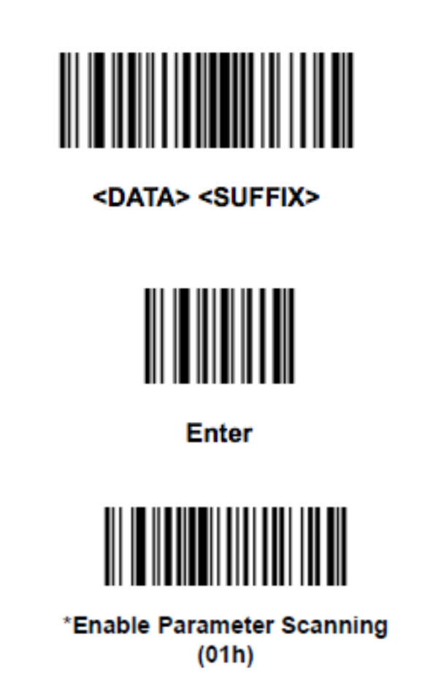

3

4

5

