

**Zebra Technologies Generated Barcodes**

File: Zebra Generated Barcodes - 1.24.2017.16.18.4.pdf

Date: 01.24.2017 16.18

**__________________________________________________________________________**

Instructions: Scan the barcodes below in the order they are listed.

**Section 1. Symbology Barcodes**

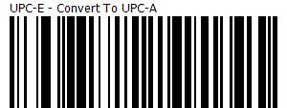

1.

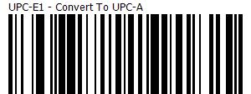

2.