This barcode should be scanned if the scanner was previously programed. When scanned, wait a few seconds before scanning the new programming barcodes. The scanner will respond with a double beep.



1.

2.

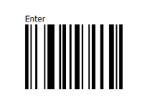3.

4.



5.



6.