This barcode should be scanned if the scanner was previously programed. When scanned, wait a few seconds before scanning the new programming barcodes. The scanner will respond with a double beep.
1.

2.

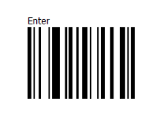
3.

4.

5.

6.

