What do I do when my hand-held scanner no longer works?  
  
Troubleshooting steps when your hand-held scanner is no longer scanning items at the front desk (Beeping like it works but not scanning items)  
  
Make sure that you unplug the scanner and plug it back into another USB slot on the computer that you are currently using.  
  
If that does not work, copy the photo of the configuration UPC provided below to another document on your computer and print that out. Once that is done, please print that out so you have a physical copy of it.  
  
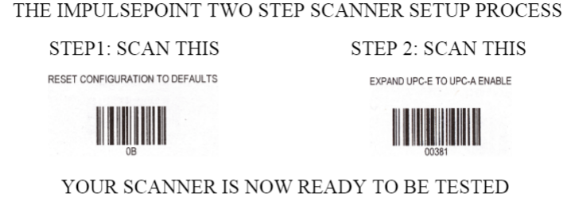  
  
Once that is done scan the UPC code with the hand-held scanner. This should reconfigure the scanner and make it so that it will start scanning the items again.  
  
In case you are still encountering issues while trying to reconfigure your scanner, please do not hesitate to contact Impulsify Customer Support. This will allow our support to diagnose and see if a new scanner is needed.