**KIOSK ORDERING PROCESS**

**PLACE A KIOSK ORDER IN SETUP MANAGER FOR:**

* NEW LOCATION
  + One Setup Manger, per new Business
  + CK requires entries in the system at least 15 Business Days before scheduled ship date, and ideally 20 Business Days from opening.
  + Within in the Notes Section of the setup manager please reference:
    - Delivery contact and phone #
    - Delivery address
    - hardware requested, please entering one of the below hardware options.
      * FEC table top
      * FEC floor model
      * MM6 w BV (includes bill validator)
      * MM6 w out BV (without bill validator)
* KIOSK “FLIP” REQUEST
  + “Flip” defined as moving a Kiosk from an existing Business or closed Business to a **NEW** Business. (“Flip” to existing business – see email request)
* KIOSK “TRANSFER” REQUEST
  + “Transfer” defined as moving an existing Business, to a new, physical address whether or not it is for the same “Company.”
* ANY OTHER KIOSK ORDER NOT ASSOCIATED WITH AN EXSISTING BUSINESS
  + “Flips” & “Transfers” require phone contact with the Support Team, at least 10 Business Days after the original Setup Manager, to complete the conversion.

**SEND AN EMAIL REQUEST TO** [**CKSUPPORT@365SMARTSHOP.COM**](mailto:CKSUPPORT@365SMARTSHOP.COM)**:**

* KIOSK UPGRADE REQUESTS FOR AN EXSISTING BUSINESS
  + Hard Drive request to upgrade software on White FEC Kiosk:
    - Request is for a hard drive for Market or Dinning Software OS Ubuntu 18.04
    - Delivery address
    - Delivery contact name and phone number
    - Business ID
    - Terminal ID
    - Shipment Date
    - Install Date
  + MM6 Hardware to upgrade Legacy Kiosk running Aeris software:
    - Request is for a MM6 Kiosk upgrade for existing Business.
    - Delivery address
    - Delivery contact name and phone number
    - Business ID
    - Terminal ID
    - Shipment Date
    - Install Date
    - MM6 Kiosk and any peripherals
* TO ADD ADDITIONAL KIOSK/S TO AN EXSISTING BUSINESS
  + Please notate in your email to Support if you plan to utilize Kiosk/s that you already possess - They will need to be “Flipped.” The Support Team requires an email notification at least 5 Business Days before phone contact is made to complete the conversion.
  + New Kiosk fulfillment will follow the same timeline referenced above.

**IF YOU ARE NOT SURE IF YOUR ORDER REQUIRES A SETUP MANAGER ENTRY, CONTACT SUPPORT - (877) 280-7373**

**ORDERING COMPANY KITCHEN KIOSKS**

*Setup Manager*

To order a Kiosk you must enter the order into our *Setup Manager*. By logging into our system you have access to this from your Main Page. **If this is your first kiosk order, your Operations Manager will place your first Company Kitchen kiosk order for you.** Once you have received login credentials to the Company Kitchen BT System, you will have the ability to place subsequent Kiosk orders on your own. If you have questions about this process after reviewing the walk through below, please feel free to reach out to your Operations Manager or our CK Support Team.

**Follow these instructions to enter a unit into Setup Manager:**

* + From the main page of BusinessTrack (our Kiosk’s back end site) pull the lower drop-down box and change it to *Setup Manager.*
  + Scroll to the bottom and click *Add Unit.*
  + A blue bar will appear next to the title *Blank Unit* – click this bar
  + A new screen will appear with blank fields – please fill all fields out**. There must be data in each field under the “General” heading or the order will not complete.**
    - For Employee Count be sure to add an additional 50 for extra cards.
    - Opening Promo should **NOT** include a $
    - In the Notes section, please notate if Setup Manager is for a “Flip” or “Transfer” from a Kiosk you have on hand.
      * Notes should also include: Delivery Address, Delivery contact and phone number, Menu information, Route, & other special circumstances
    - Install Date should reflect actual date the customer expects the installation to begin.
    - Ship Date should generally be at least 5 Business Days prior to the Install Date & at least 20 Business Days from the date you are entering the order into Setup Manager.
    - **If you don’t have any information for certain fields, please enter an N/A and 0 numerical for any number (#) fields.**
    - 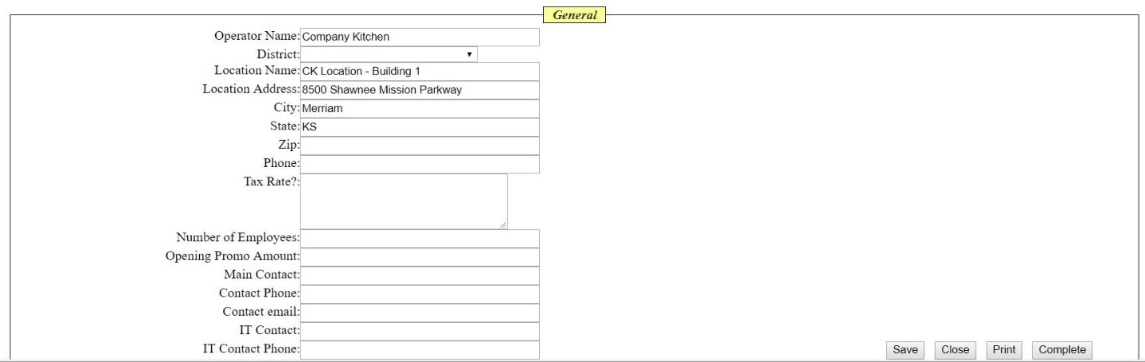“# of Kiosks” will always be at least 1 even if the Entry is for a “Flip” or “Transfer”

**CK TIPS\*** - *Setup Manger entries should always have at least a 30 day lead time from date of entry to installation date! If you enter an order under 30 days to Installation please contact your Operations Manager or the Support Team Staff to confirm the requested Installation timeline.*